DOCKER

### **What** **is** **Docker?**

Docker is an **open-source centralized platform designed** to create, deploy, and run applications. Docker uses **container** on the host's operating system to run applications. It allows applications to use the same **Linux kernel** as a system on the host computer, rather than creating a whole virtual operating system. Containers ensure that our application works in any environment like development, test, or production.

### Docker includes components such as **Docker client, Docker server, Docker machine,**

### **Docker Containers**

Docker containers are the **lightweight** alternatives of the virtual machine. It allows developers to package up the application with all its libraries and dependencies, and ship it as a single package. The advantage of using a Docker container is that you don't need to allocate any RAM and disk space for the applications. It automatically generates storage and space according to the application requirement.

### **Virtual Machine**

A virtual machine is a software that allows us to install and use other operating systems (Windows, Linux, and Debian) simultaneously on our machine. The operating system in which virtual machine runs are called virtualized operating systems. These virtualized operating systems can run programs and preforms tasks that we perform in a real operating system.

### **Containers vs. Virtual Machine**

|  |  |
| --- | --- |
| **Containers** | **Virtual Machine** |
| Integration in a container is faster and cheap. | Integration in virtual is slow and costly. |
| No wastage of memory. | Wastage of memory. |
| It uses the same kernel, but different distribution. | It uses multiple independent operating systems. |

## Advantages of Docker

There are the following advantages of Docker –

* It runs the container in seconds instead of minutes.
* It uses less memory.
* It provides lightweight virtualization.
* It does not a require full operating system to run applications.
* It uses application dependencies to reduce the risk.
* Docker allows you to use a remote repository to share your container with others.
* It provides continuous deployment and testing environment.

## How to install Docker in server

We already have an instance and connected.

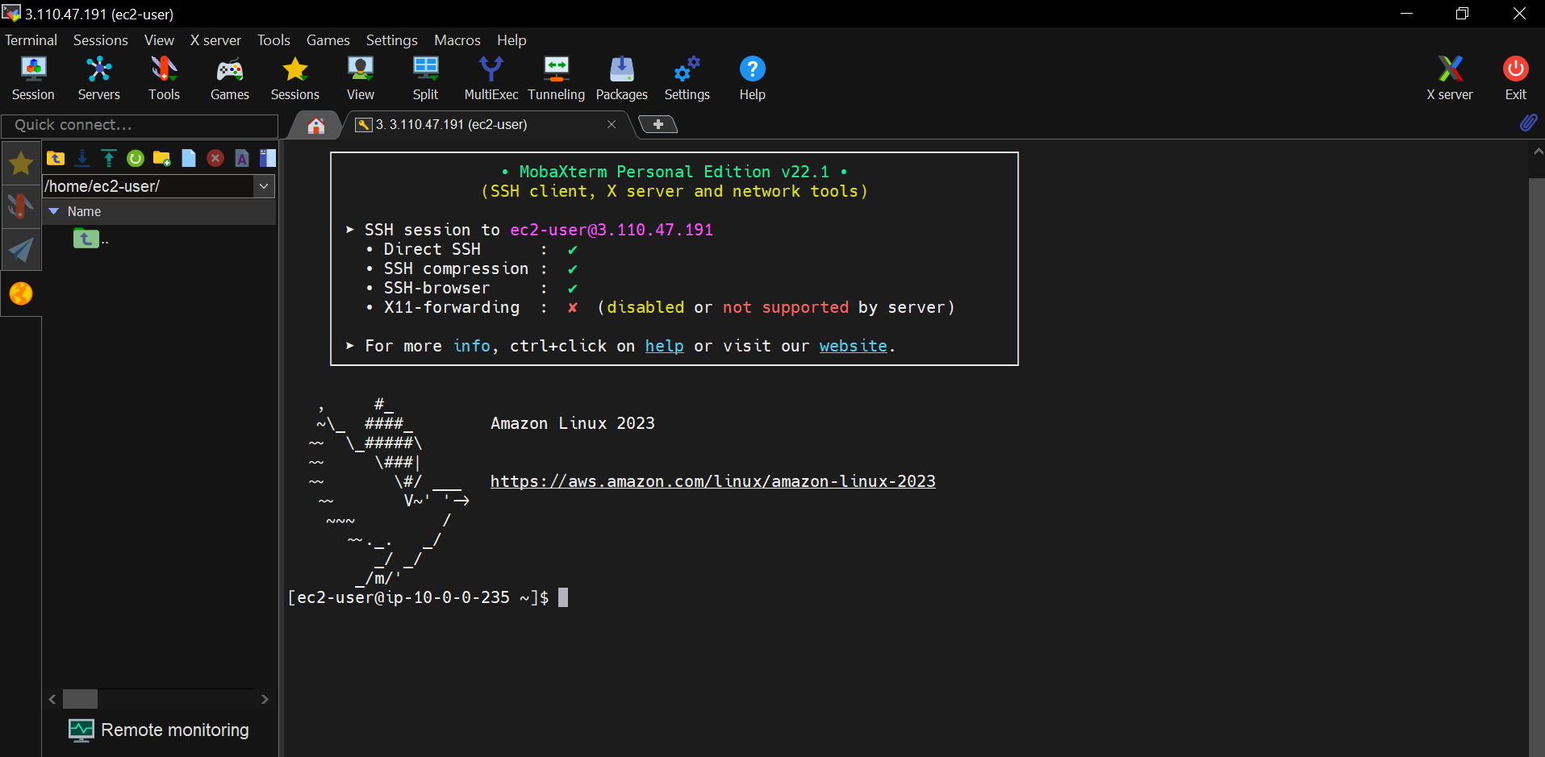

First we create a Docker account in Docker Hub.

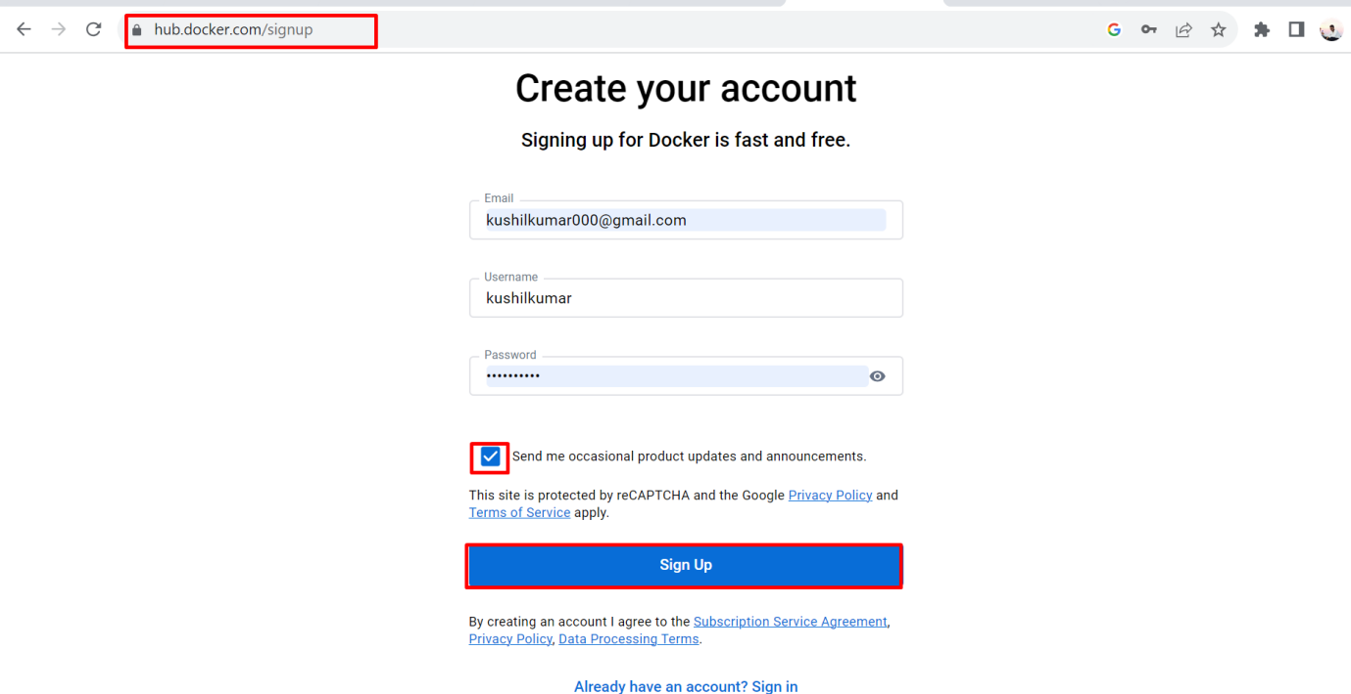

We successfully created Docker account.

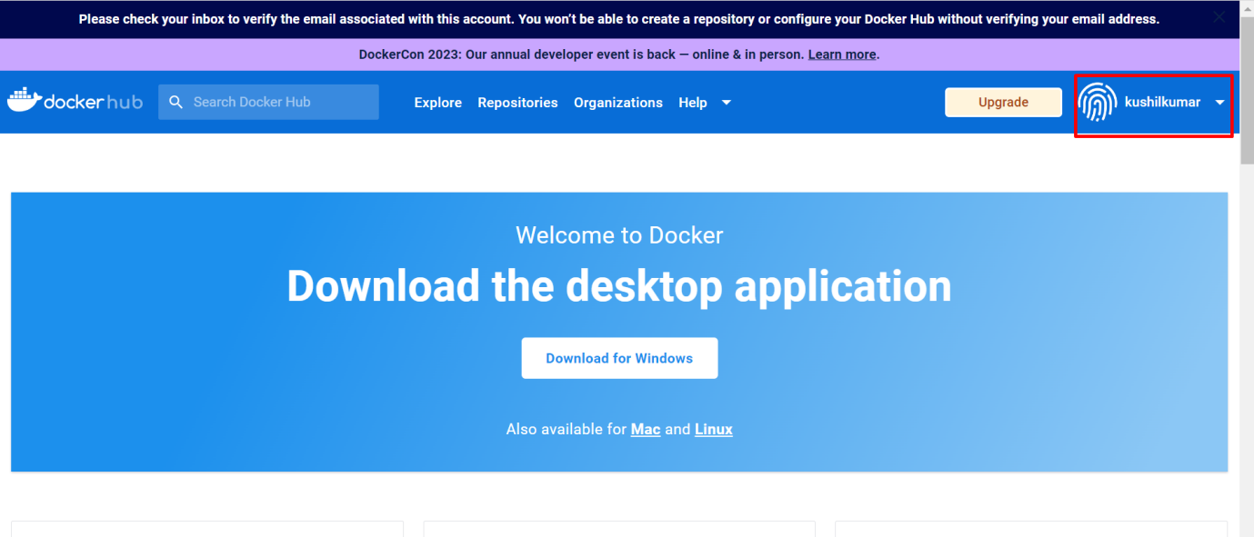

After that we install Docker in our server.

Commands for installing Docker on Linux server

* sudo yum update
* sudo yum install docker –y

After that we check docker is installed or not in our server

To check docker version

* docker –version

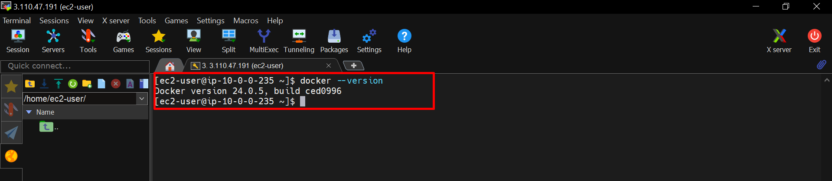

We successfully installed docker on Linux server

Now we start docker and check status is active or not

Commands:-

* sudo systemctl start docker
* sudo systemctl status docker

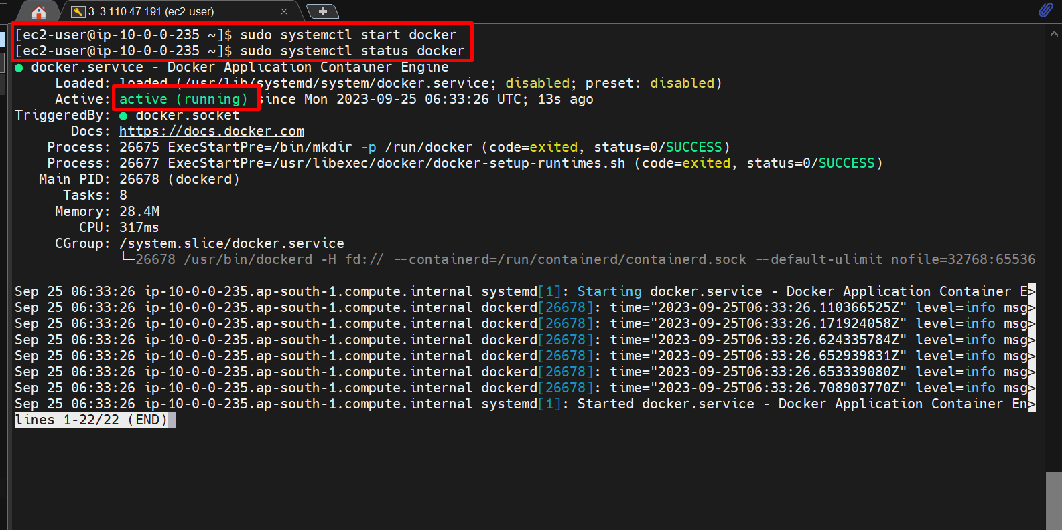

After that we pull docker images (Ubuntu) from docker hub

Go to **docker account** – Search **Ubuntu** – click **Ubuntu** – copy **docker pull Ubuntu** code.

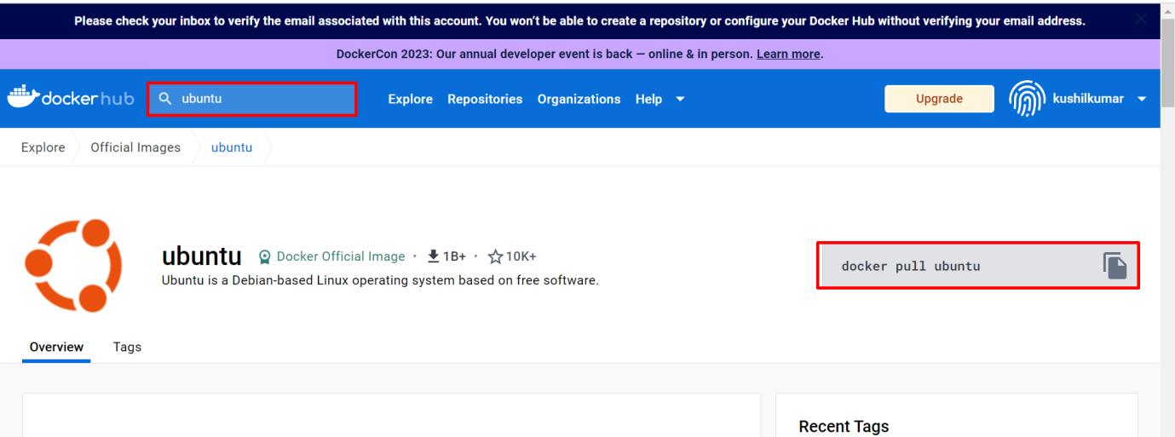

After that paste that code in Linux server

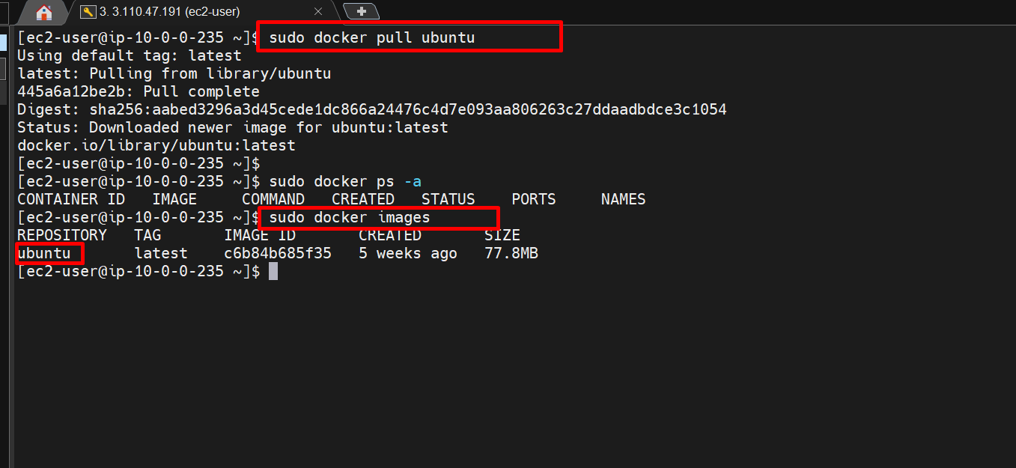

We successfully create a docker image (Ubuntu)

After that we create a container with that docker image

Commands:-

* **sudo docker run –it Ubuntu** # (To create container)
* **cat /etc/os-release** # ( to check where we are in)

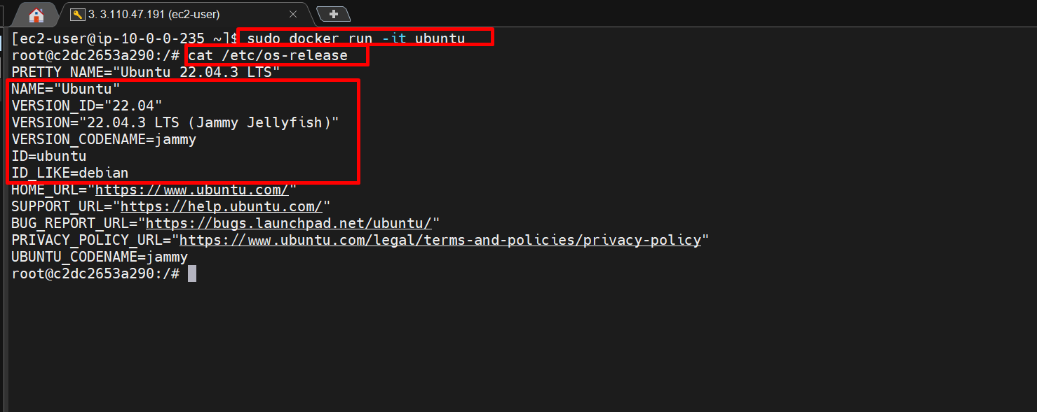

Now we check the Ubuntu container created or not

Commands:-

* sudo docker ps # ( To check active containers)
* sudo docker ps –a # ( To check all (active or inactive) containers)

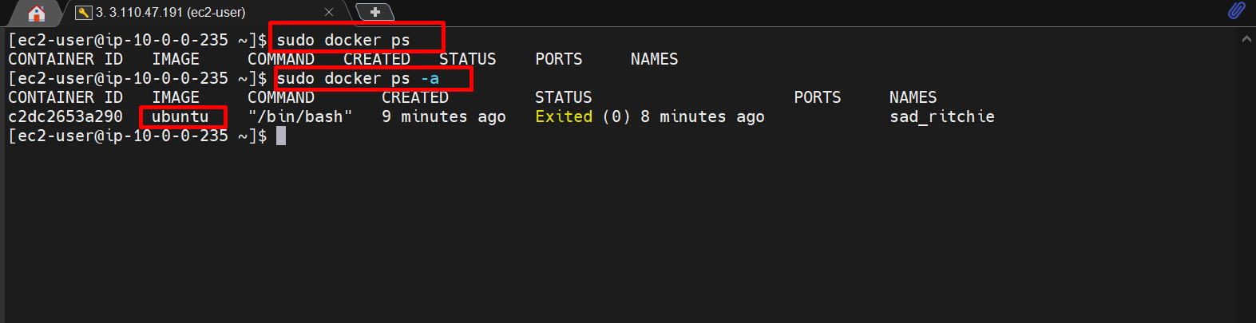

Here we already create Ubuntu container but that container doesn’t shows in active, it shows inactive container then we want to active that Ubuntu container

First we change Ubuntu container name to our required name

Commands:-

* sudo docker run -it --name kushil ubuntu

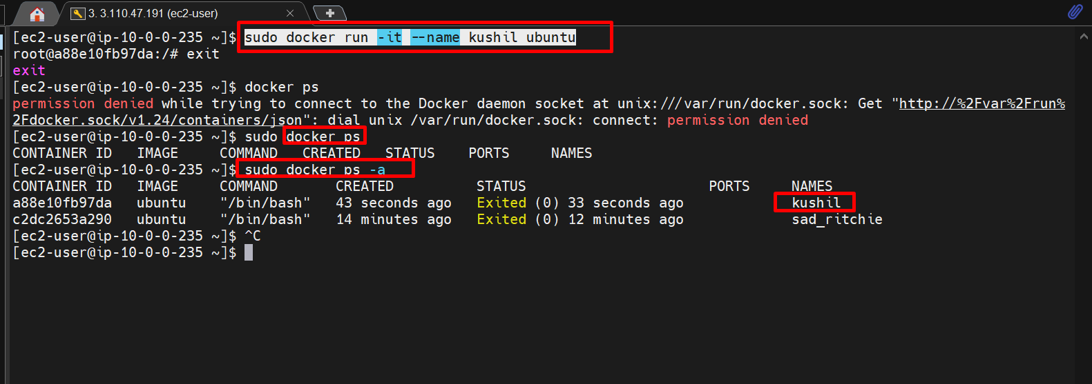

After that we start (active) our container

Command:-

* sudo docker start kushil

Now we active our ubuntu (kushil) container and check **sudo docker ps** command for showing active containers.

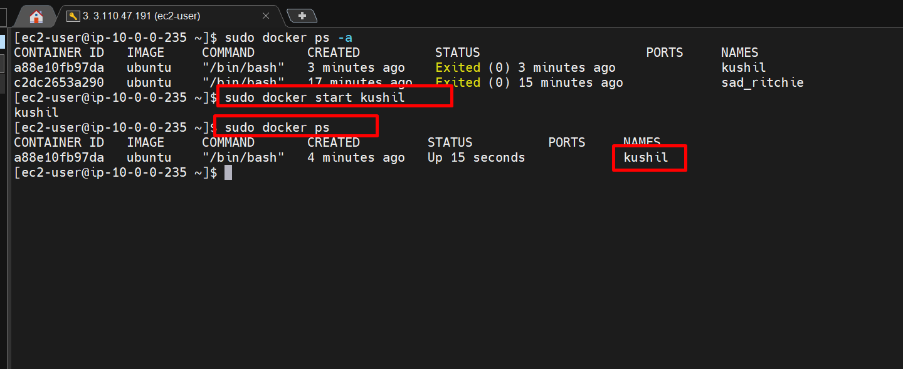

After that we go to in docker container (ubuntu)

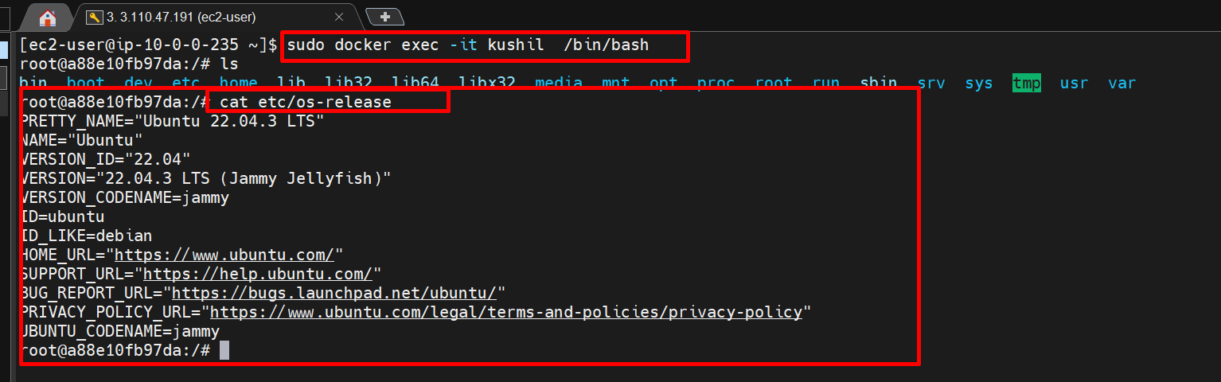

Now we will installed **nginx** (web server) in docker and create an html code in that nginx path and see that output in web browser.

Go to **docker hub** – search **nginx** – click **nginx** – copy **docker pull nginx** code.

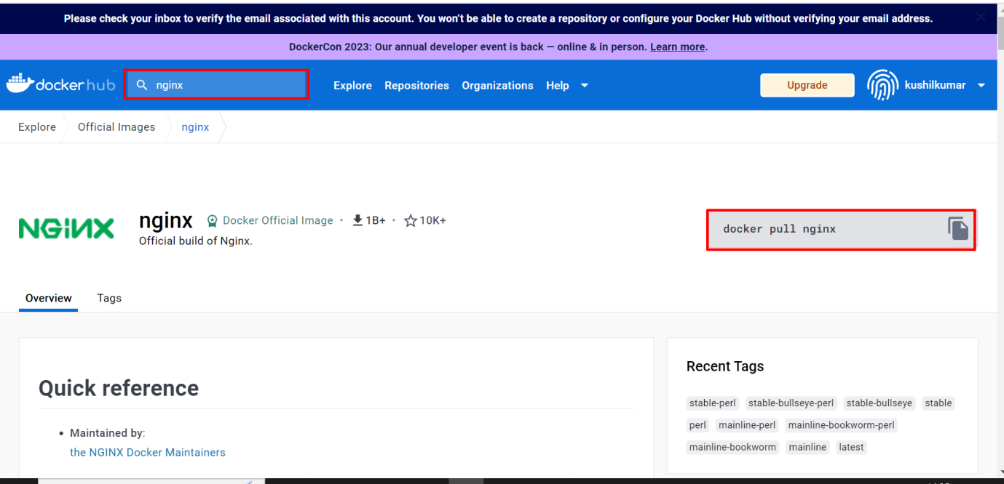

After copying that command and paste in server

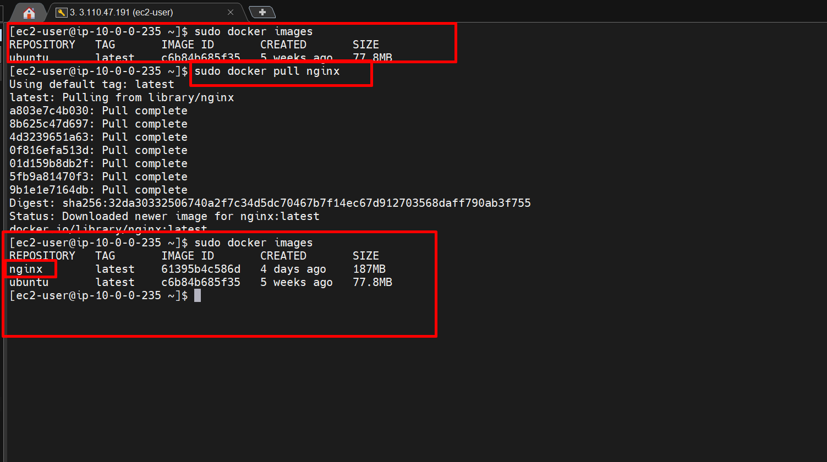

After that we create container nginx with name and start that container

Command:-

* sudo docker run -d --name my_nginx_container -p 80:80 nginx

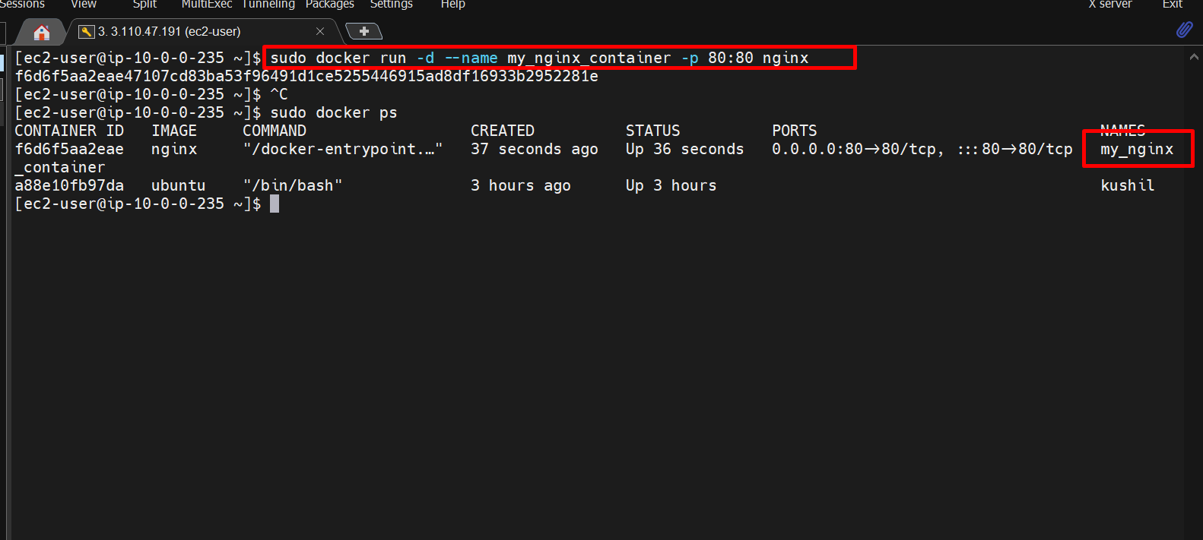

After that copy public ip of the instance and paste in web browser.

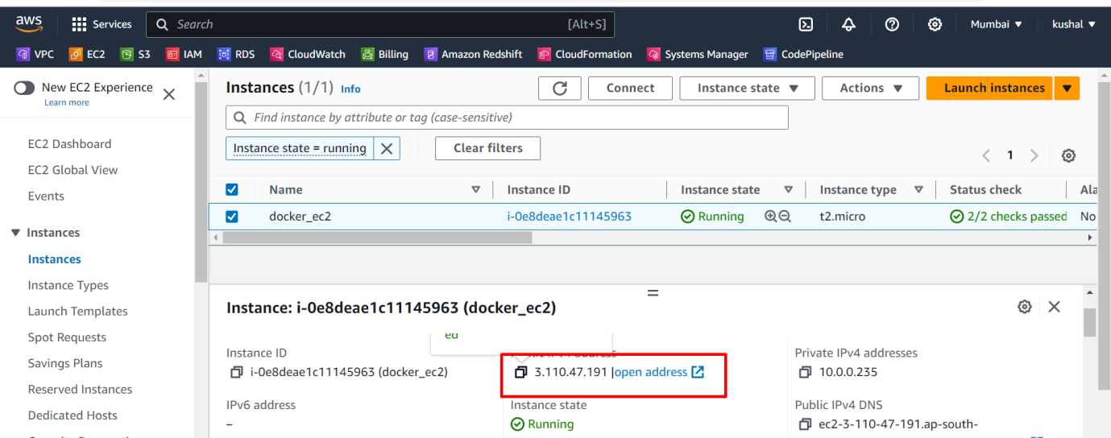

We successfully connected.

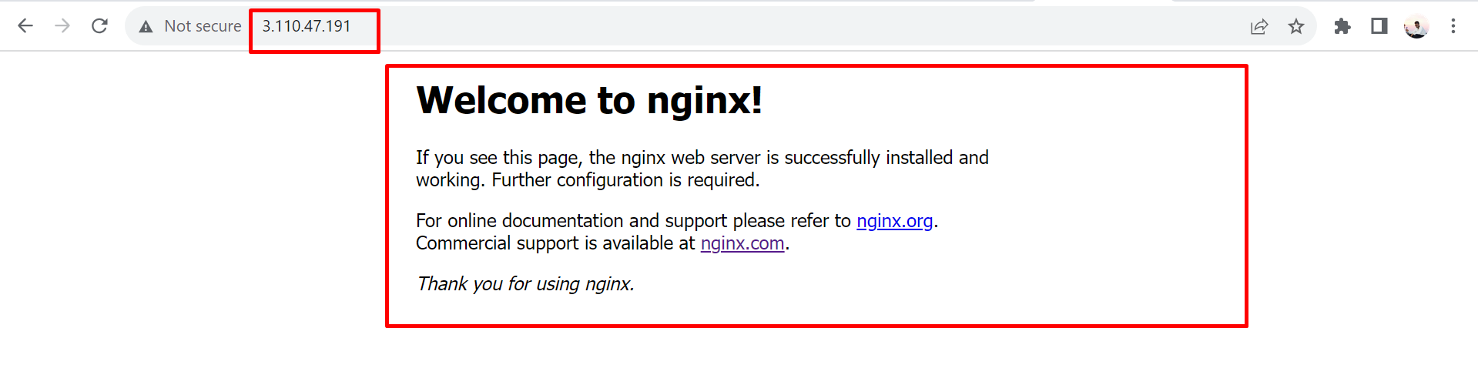

Now we want to create our new html code in nginx path

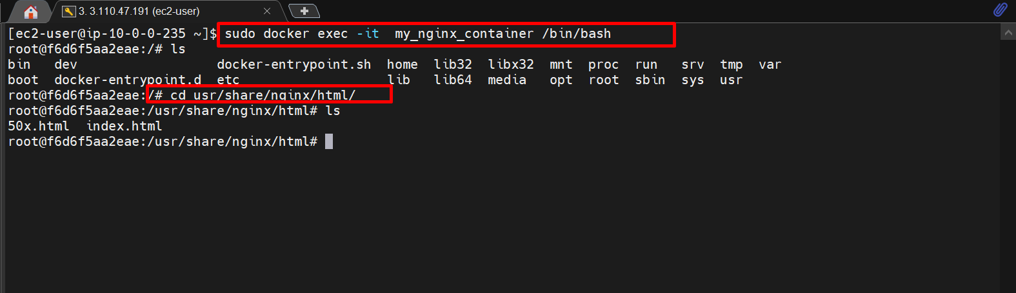

Copy our html code

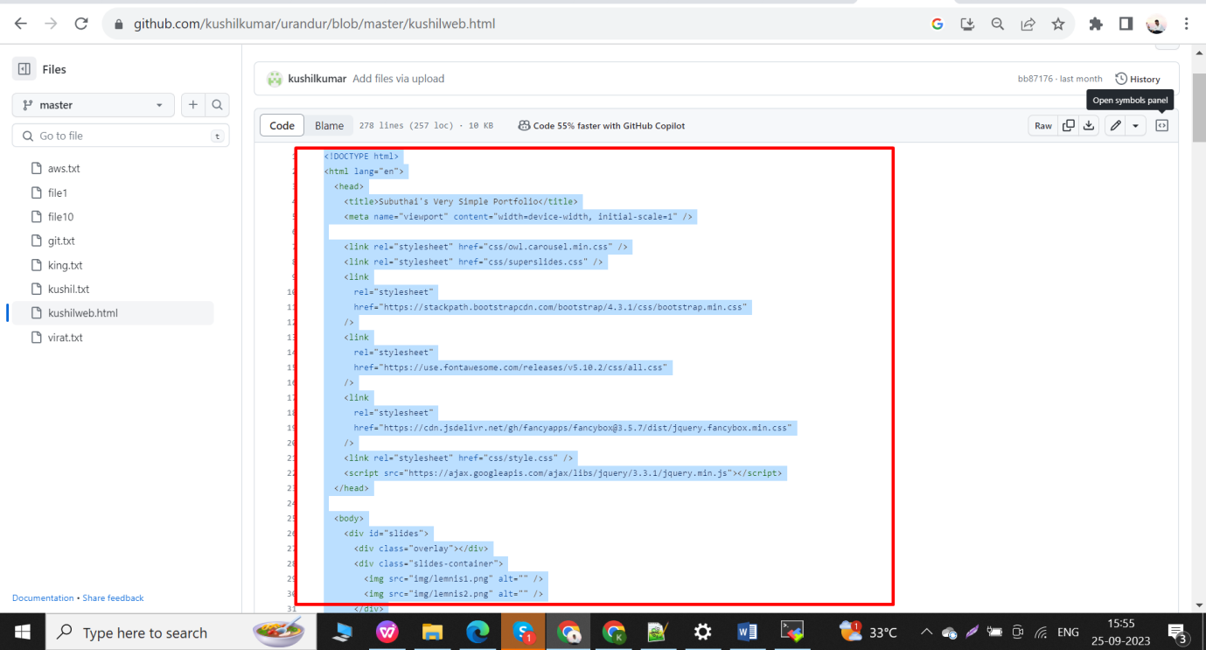

After that we go nginx container path and create a new file with our required name but the extension must be .html

Here I create a web.html file using

Command: - vim web.html

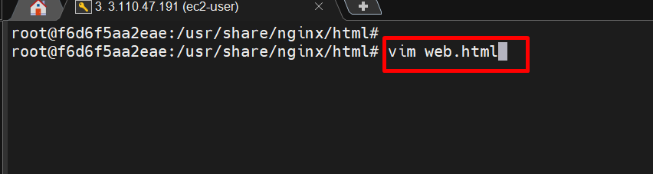

After that we paste that html code in that web.html file using insert button and finally save that file enter **escape** button and enter “**:wq!”** and click **enter**

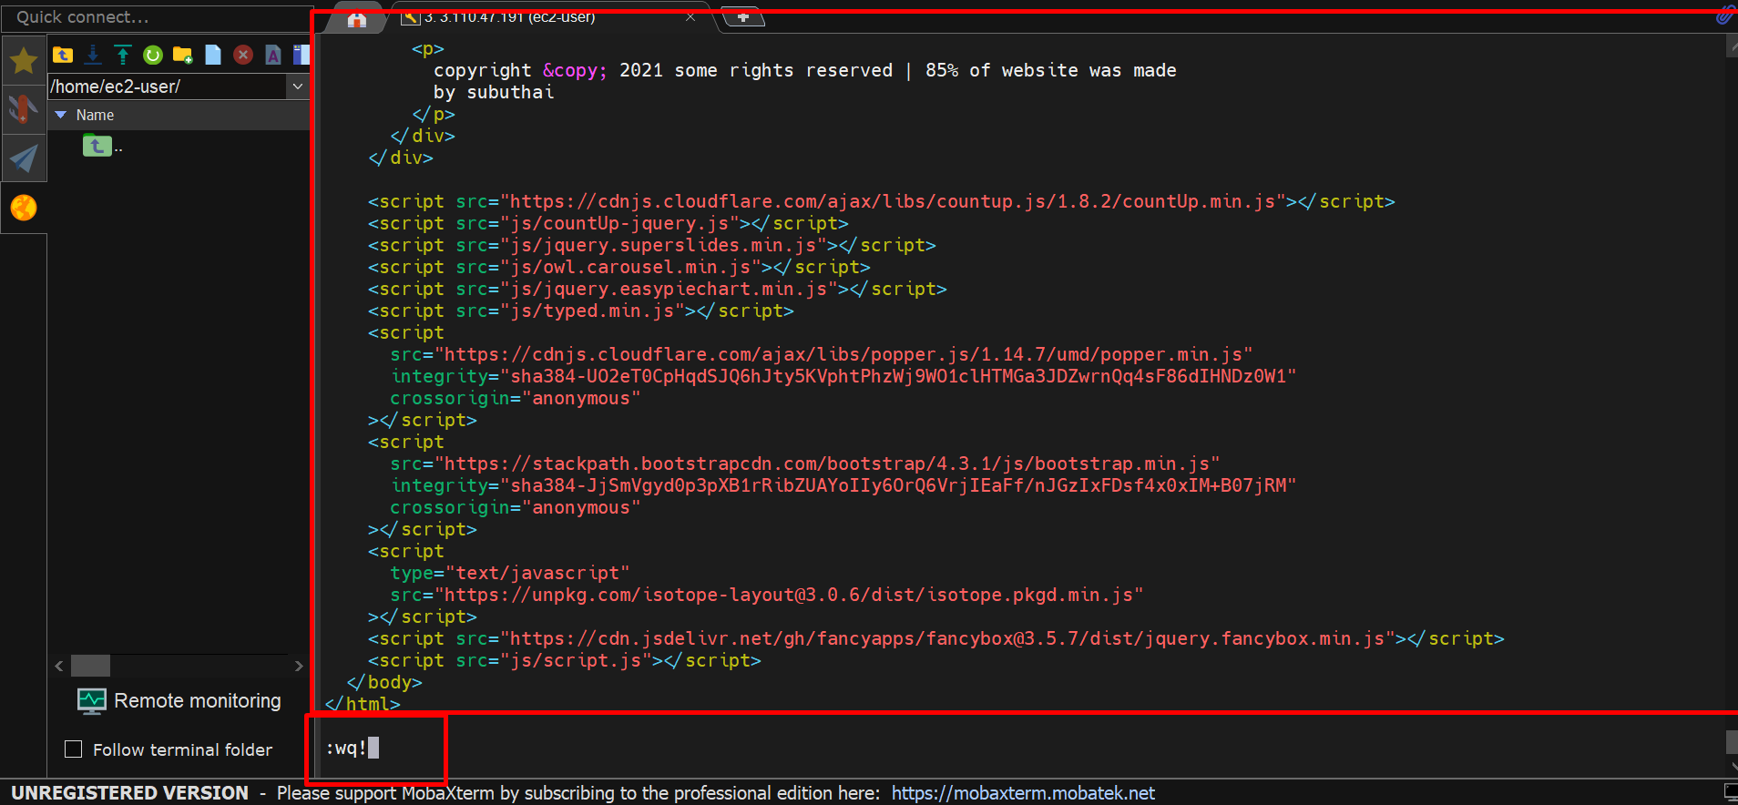

We successfully created web.html file

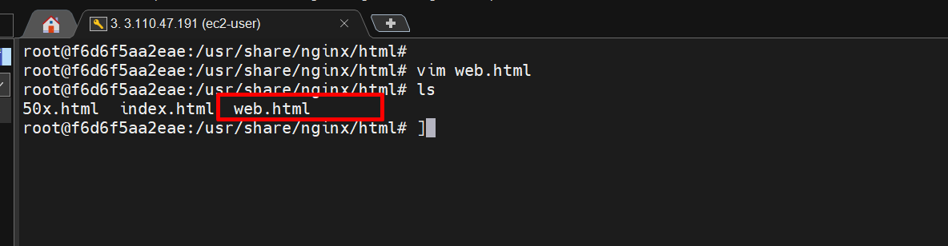

After that go to web browser and enter public ip of the instance and click enter showing default page of nginx using “ / “ and enter web.html in browser like “ 3.110.47.191/web.html “

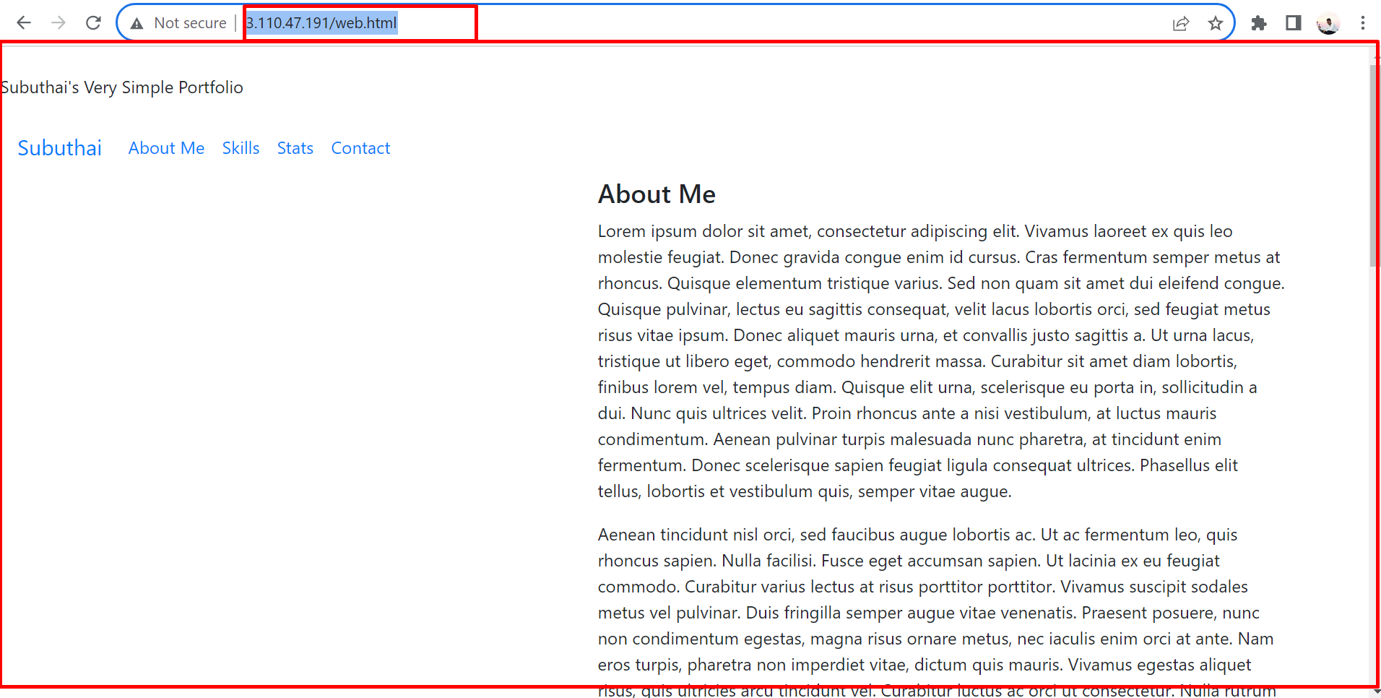

This data contained in our web.html file.

This is the process for installing docker in server and docker images from docker hub and create container with docker images and also installed nginx web browser and browser our html code in nginx.

 THANK YOU